CISC 327 GROUP-51 readme first

How to run payment feature program and test cases (Sungmoon Choi):

* Change the directory to Payment directory inside Assignment-2
* Create a virtual environment (this command is using Windows, the command is

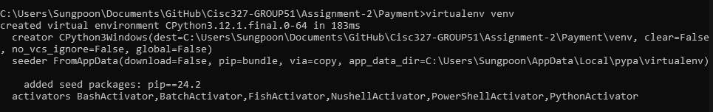different depending on the operating system)

* activate the virtual environment



* Using pip to install the required packages

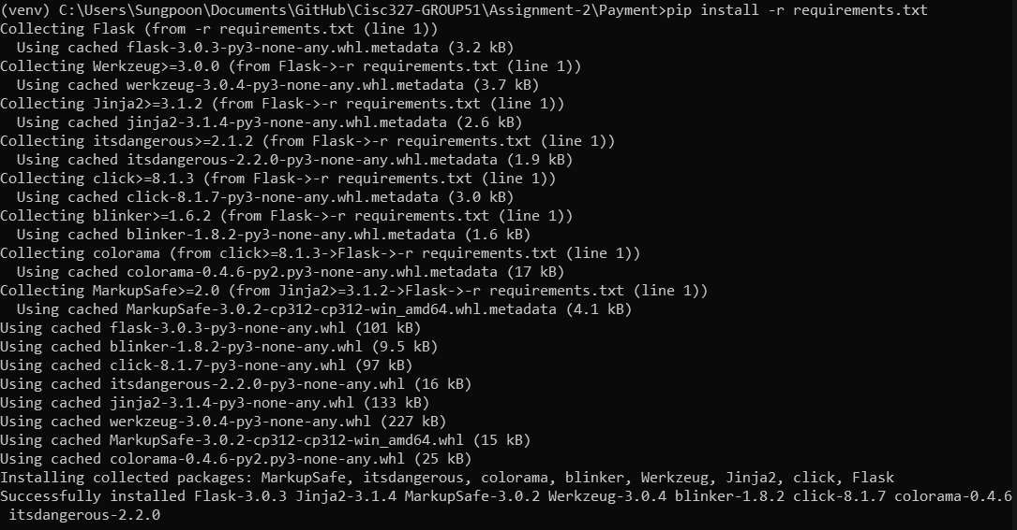

* now run app.py to start the program

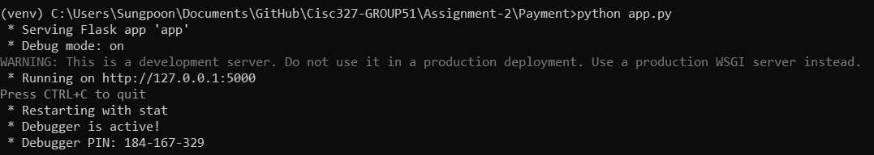

* typing http://localhost:5000/ into the browser will load the website for payment feature

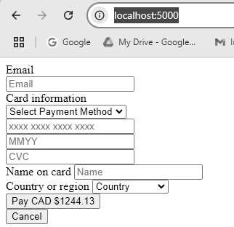

* 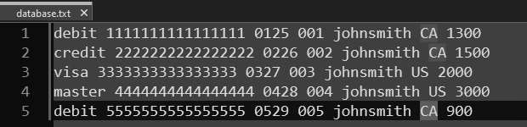from here, you can manually test by inputting information as written in database.txt (note that name is written in lower case with no space, this is because program is made to interpret name input as such, for example, "John Smith" will be interpreted as "johnsmith")
* **or to run the test case, run the command "python -m unittest discover -s tests"**

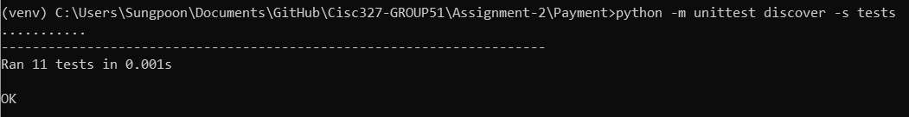**(note that 11 tests include both success and fail cases)**

**fail cases are tested by ensuring that no balance is returned if any of the information is incorrect, thus returning an error message on the website**

**Running the Registration program and test cases: Steven Guan**

**-- ENSURE YOU HAVE FLASK INSTALLED BY RUNNING (PIP INSTALL FLASK) IN THE BASH TERMINAL --**

**To look at the page for registration:**

1. Start by opening a new terminal make

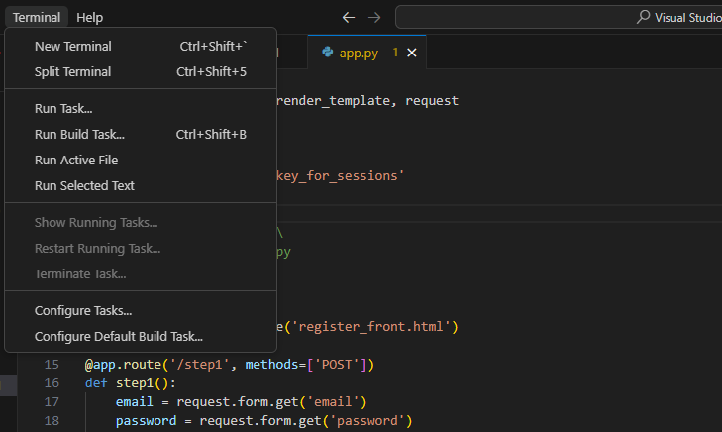2. Ensure that the current directory is where you can access all the images, css, html and python files. Run the app.py by running ”python app.py” in the terminal.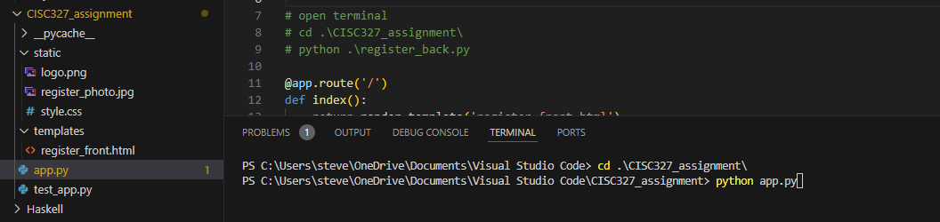

3. Copy the url that the terminal gives you and paste it into your browser. Once you are done, exit the page by Ctrl+C on the terminal.

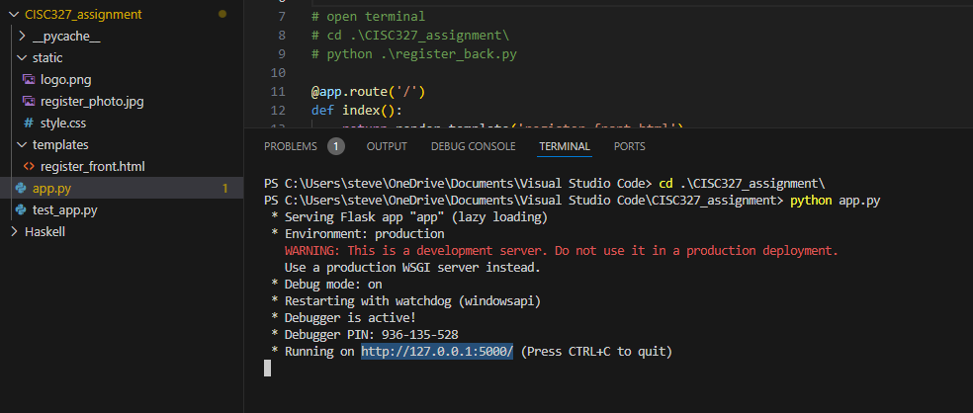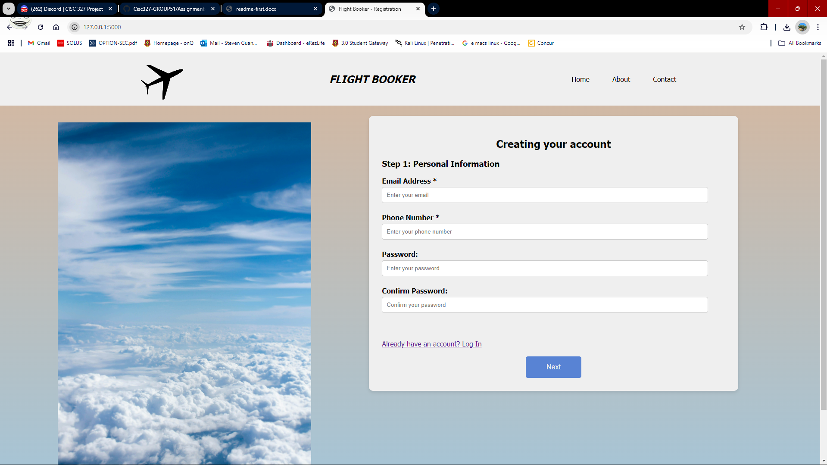

**To run the test cases and start a test case:**

1. In the same working directory as you opened the page, run “python test_app.py”

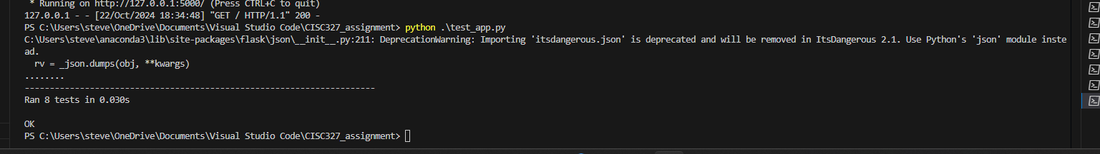

1. In the test_app.py file, you may alter the values of the html forms to try testing for yourself and building test cases. The logic can be found in app.py for returning 400 (failure) or 200 (success).

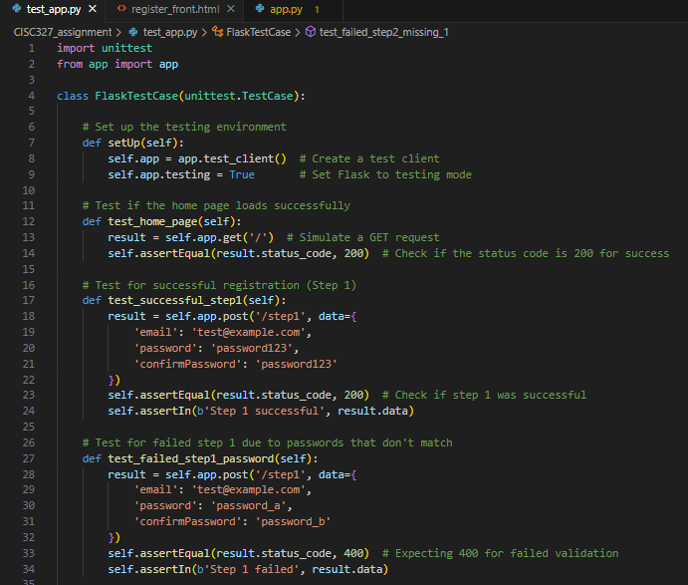Replacing the value of ’email’, will change the input value of the form submission with the id ’email’.